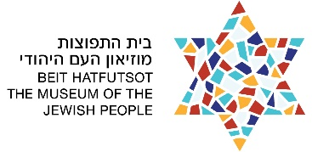# I’m that

__________________

Jew!



# I’m that

__________________

Jew!