Pedagogical Games Workshop

Purpose: Familiarity with various pedagogical methods that can be integrated into educational training in museum spaces.
Duration: 90 minutes

- The classical method of telling the story of the mosaic floor
Before we start the tour, we will organize the group in a circle, we will ask the students to whom the following statements are valid and whoever it resonates with rases their hand:
- I enjoy watching theatre or acting in theatre plays
- I have fun dancing
- I play a musical instrument (ask those who raised their hand which instrument they play, collect some answers)
- I like to draw or doodle
- I enjoy immersing myself in a good book
- I am an avid sports fan
- And the most important statement: when I do all the things we have listed – sports, literature, dance, theater, art and music, I feel connected to my Jewish roots.
Because it is likely that the last statement will receive only a few votes or not at all.
After this method, instruct on a figure on the floor, and finally we will reiterate what we said in the opening that our identity is composed, among other things (and sometimes mainly) of our interests and hobbies, but in the cultural centers we see how Jewish identity is expressed not only on a personal level but can also be expressed through art.
- Search for objects in a specific space – a nice and easy method suitable for each floor and exhibition
The effect of the method is that you release the students for a task in a specific space, by allowing them to experience the museum independently alongside your guidance that will be before and after.
As experienced instructors, you can describe to the group what is presented in a hint and send them to look for it, in the workshop now we will experience the method through this bingo:
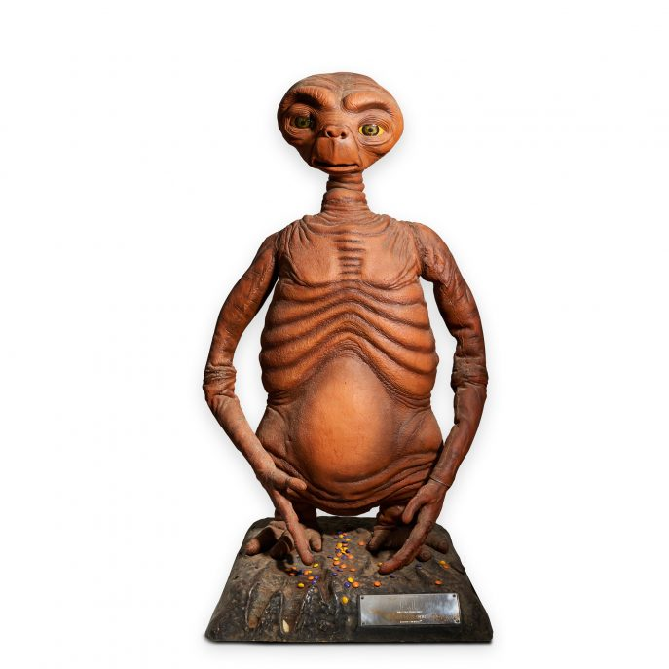 | 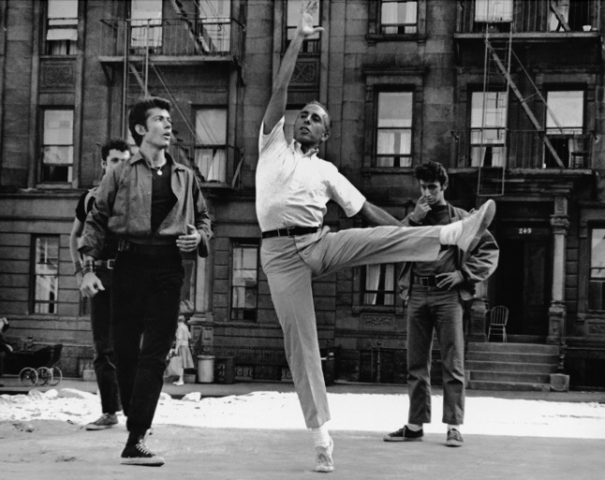 | 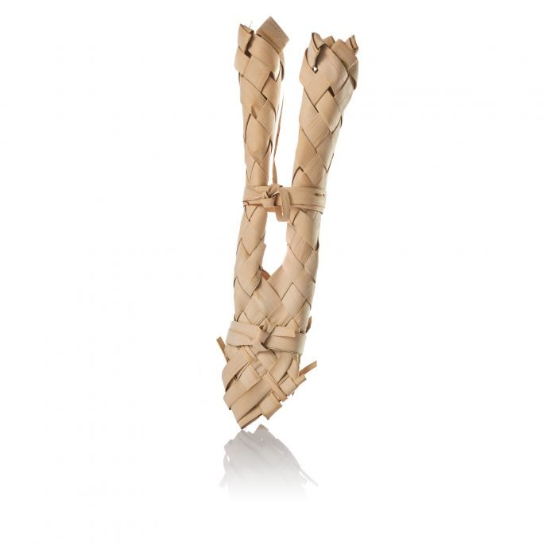
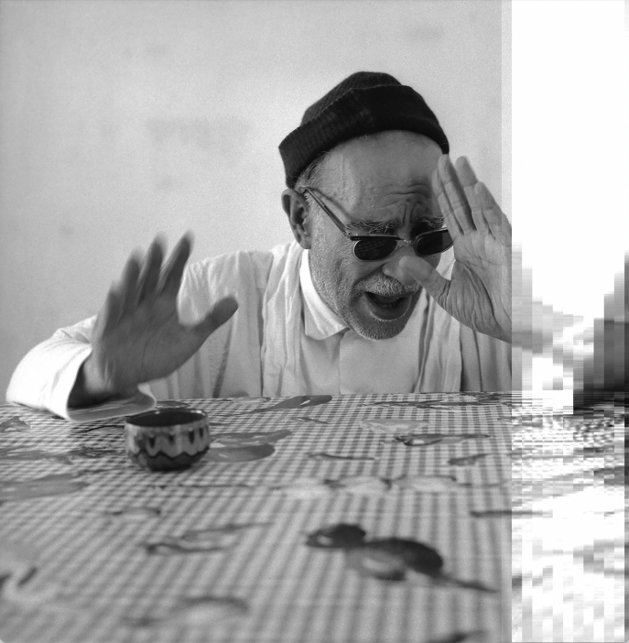 | 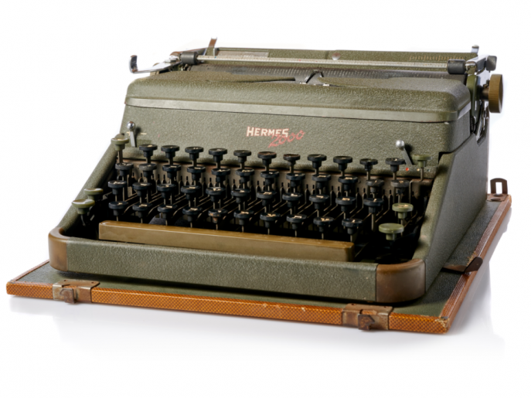 | 
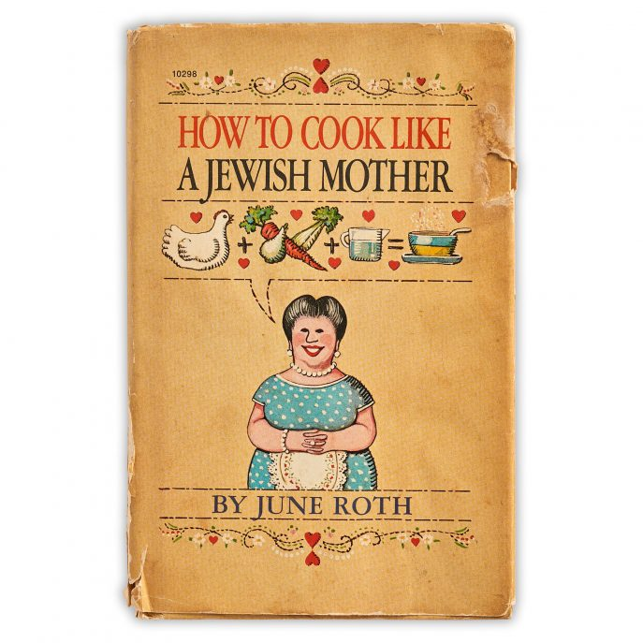 | 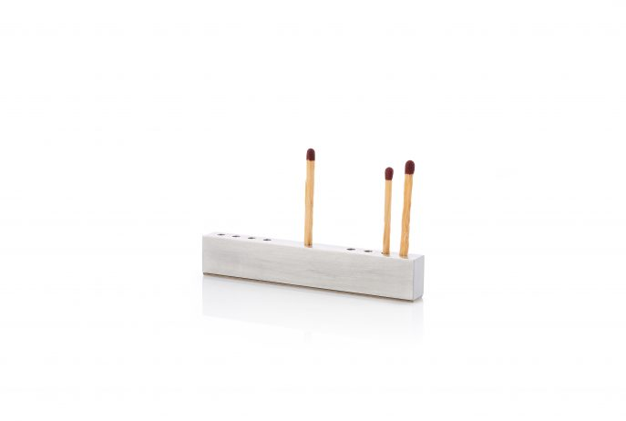 | 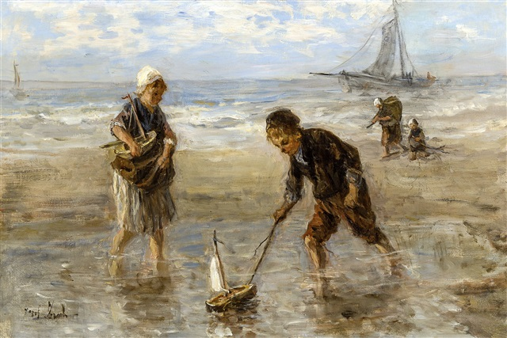

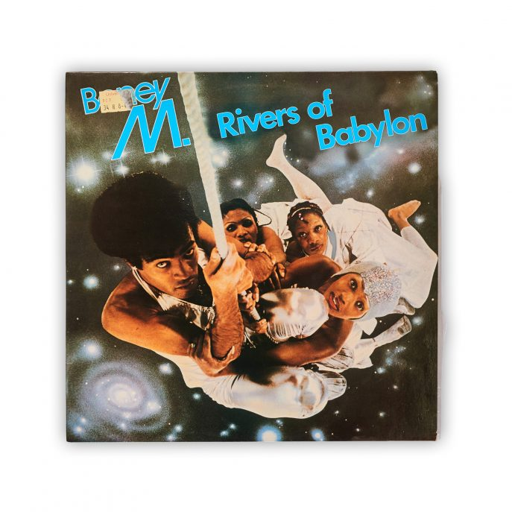 | 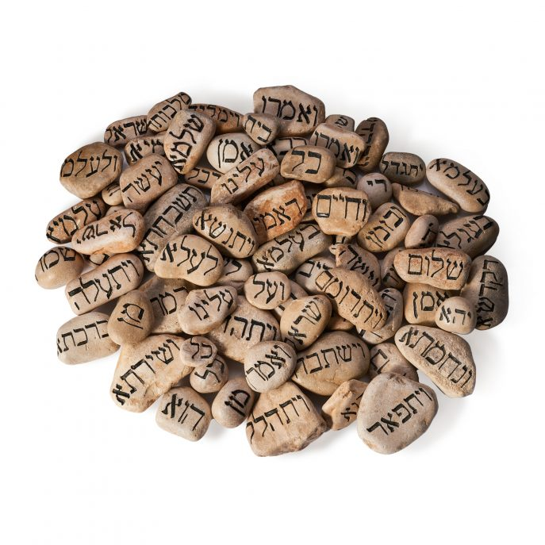 | 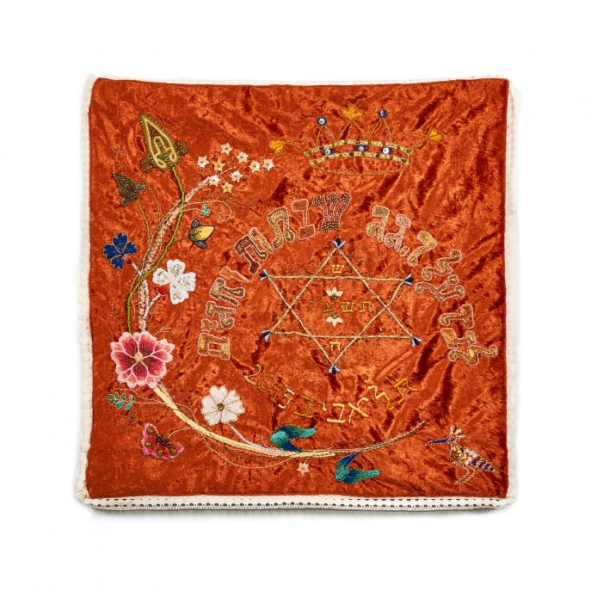
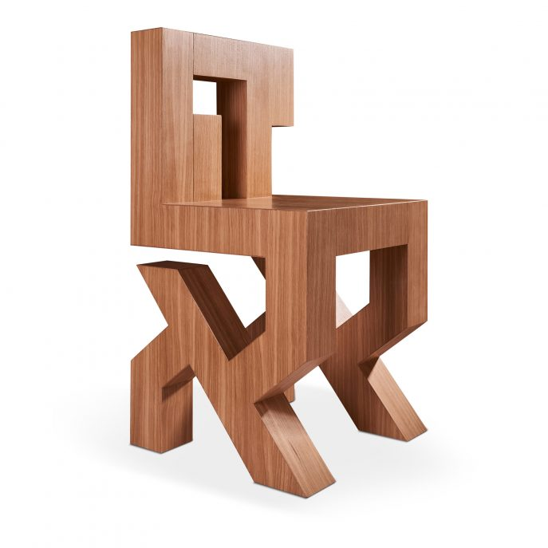 | 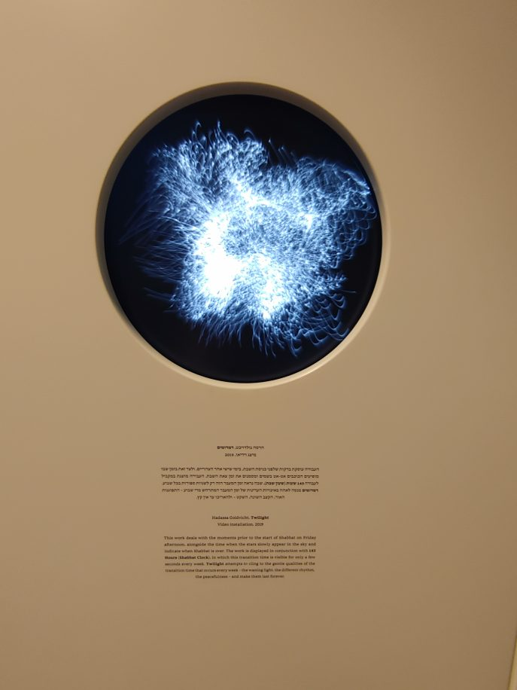 | 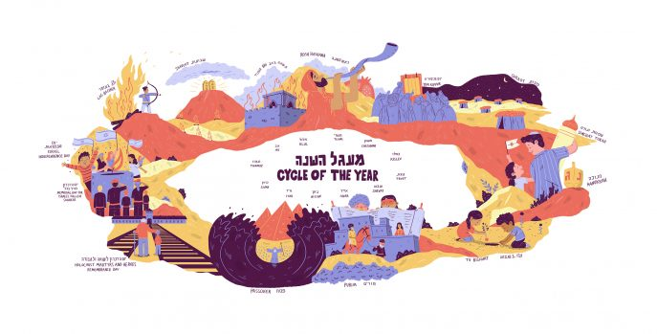
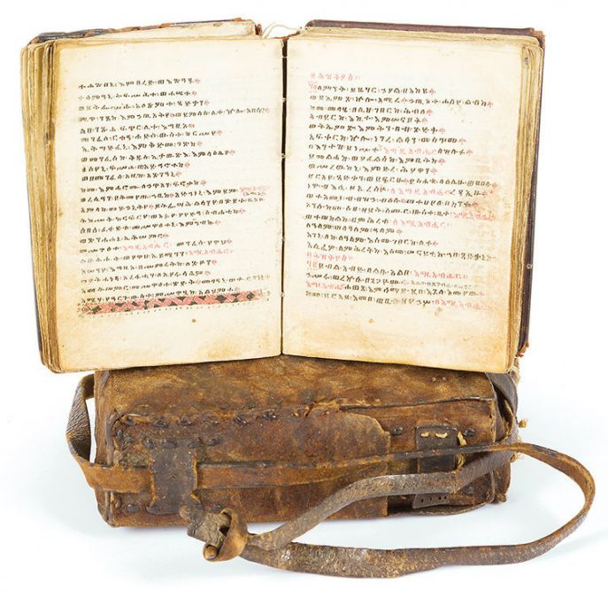 | 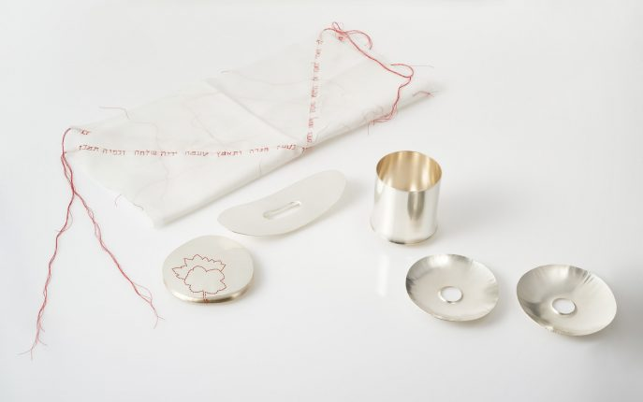 | 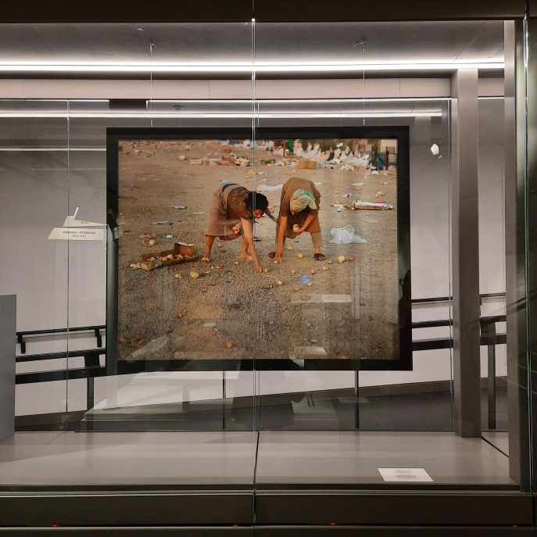

- Image midrash – creating relevance and personal connection through the personal impression of the observer
The instructor will place the group in front of an exhibit containing figures and ask the volunteer to talk as if he were the character in the exhibit – the volunteer is actually required to observe and try to understand the situation that is happening and reflect the feelings and thoughts of the character. After observing, the guide will complete the details of the information about the story of the exhibit.
Good exhibits for this method: Diorama of Shmuel HaNagid, Diorama of Dona Gracia, Diorama of the Cairo Genizah, Sinagoga and Ecclesia sculptures.

- The video watching method- an activity that ensures that students watch the video attentively
The guide will instruct the students before watching the video that they should pay close attention and make a physical gesture when things appear in the video. For example, in a video of Sha'anan Street, ask students to raise their hand when a cultural figure they know appears. More ideas: Leaders/countries/A significant event in your eyes in Jewish history.

- History is resurrected – an introduction to the main activities of "ANU HaMassa children"
The program's activity – to carry it out in at least two stations, and it is also recommended to divide the participants into groups that compete on whoever manages to dress the character in as many historical items as possible.

- Hints in the exhibition – a simple activity that should be done in a limited space
The guide/representative thinks of a display in the exhibition, and gives the other participants an attempt to ask 3 yes/no questions to find out what the exhibit in question is. For example, the Moroccan dress on the 2nd floor.

- A museum memory game – a simple activity suitable for any object full of details
The instructor gives a representative 20 seconds to look at an object and then the volunteer turns his back to the exhibit and describes it to the group with as much detail as possible that he remembers from the picture. For example, the illustration of the Jewish Sephardi and Ashkenazi towns on the 2nd floor, the pictures of the families in the Moderna or on the mosaic floor.

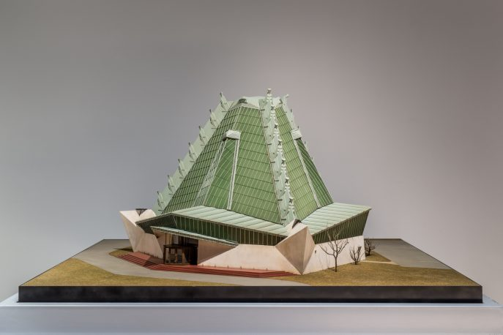 | 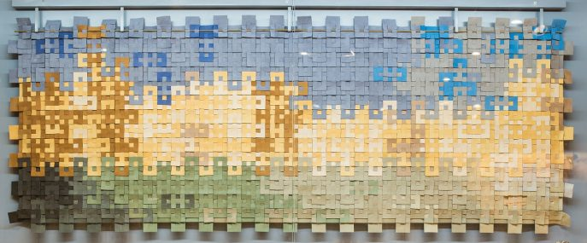 | 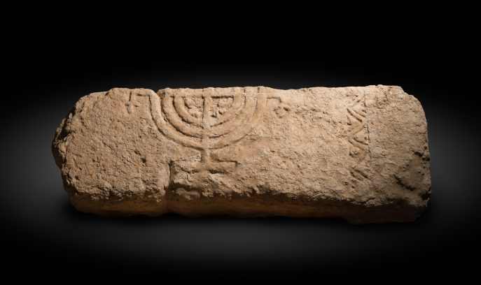
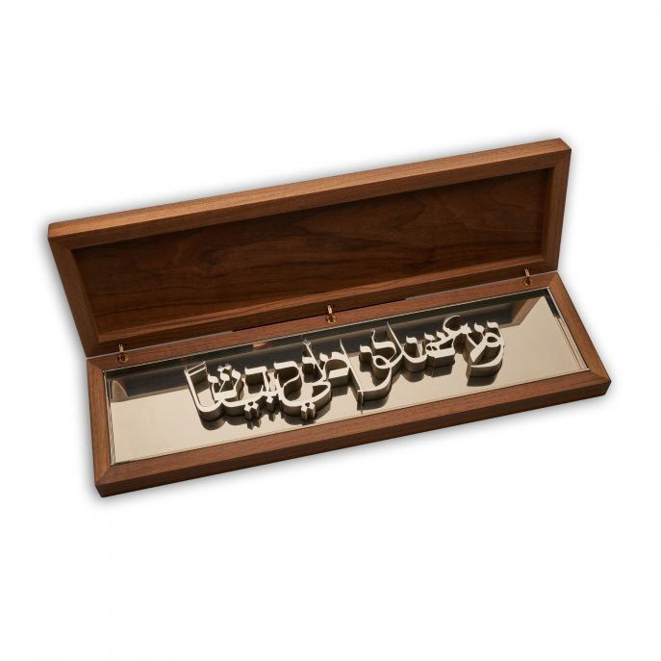 | 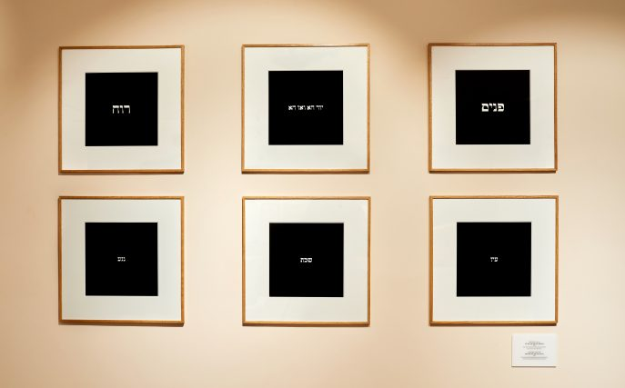 | 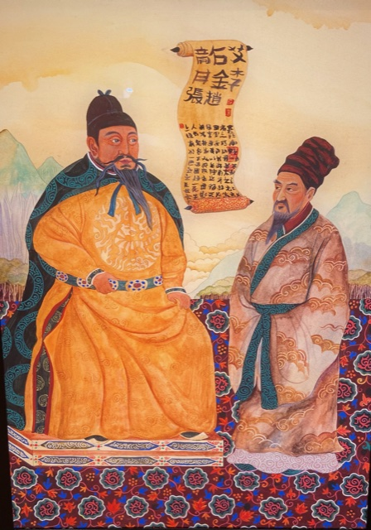
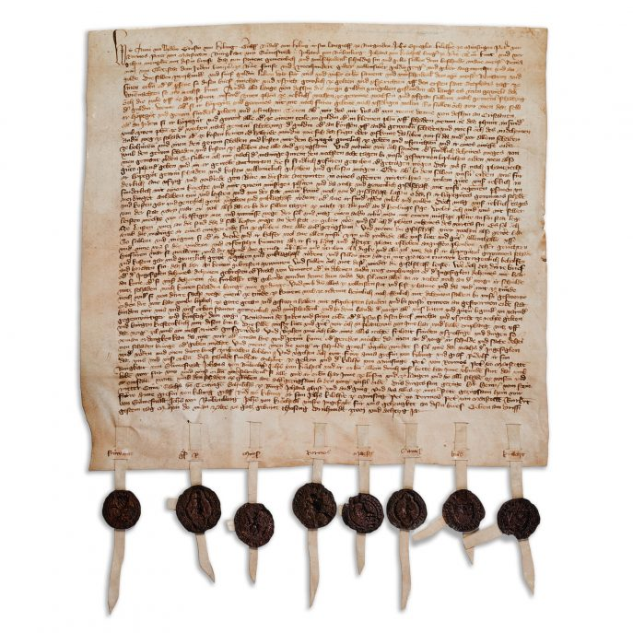 | 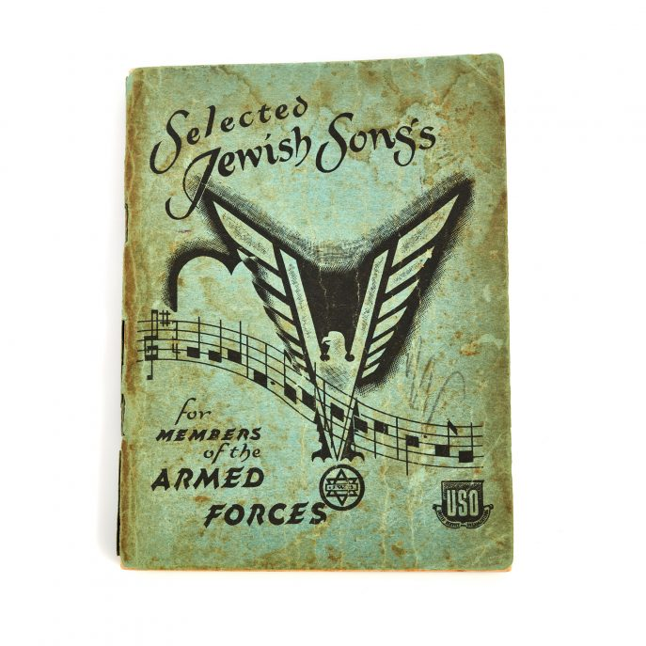 | 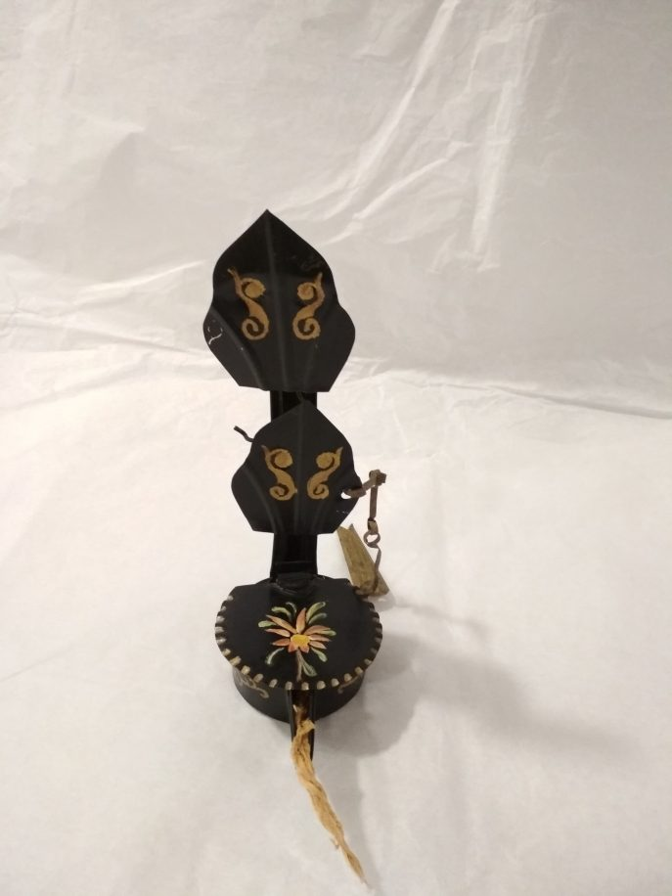
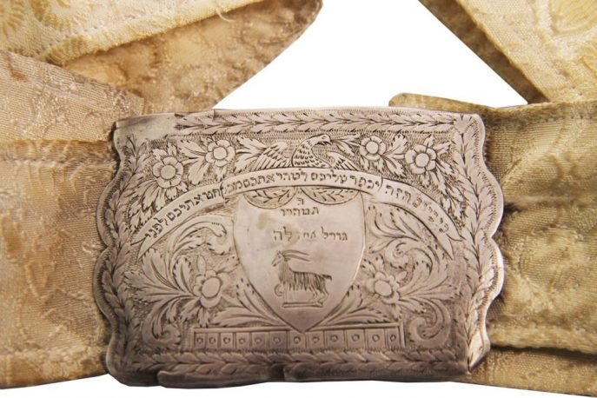 | 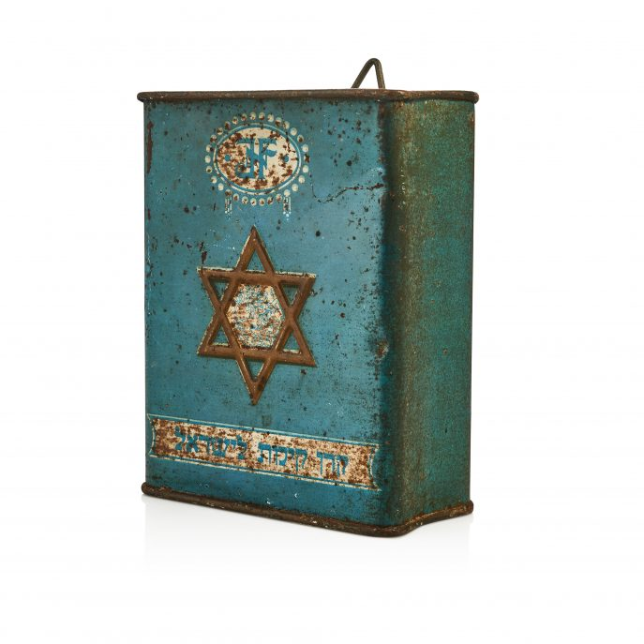 | 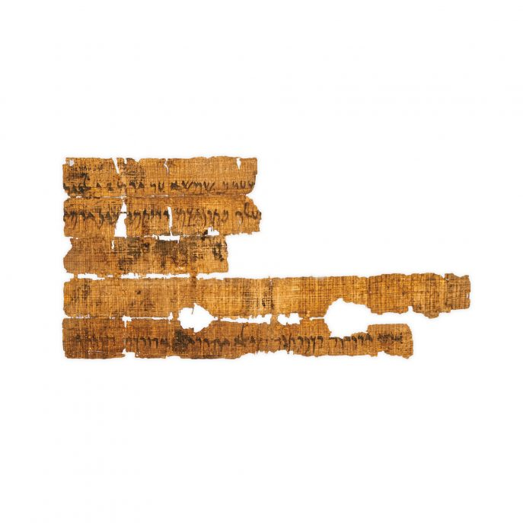
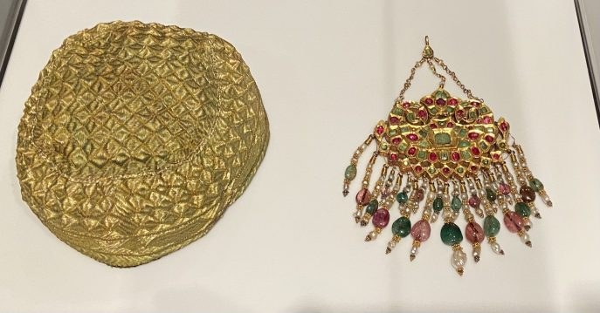 | 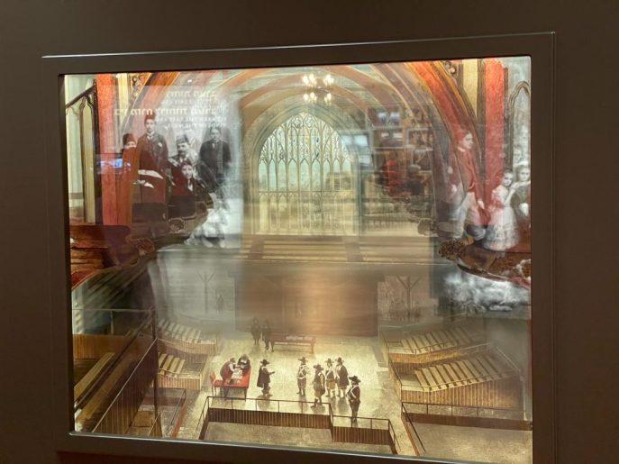 | 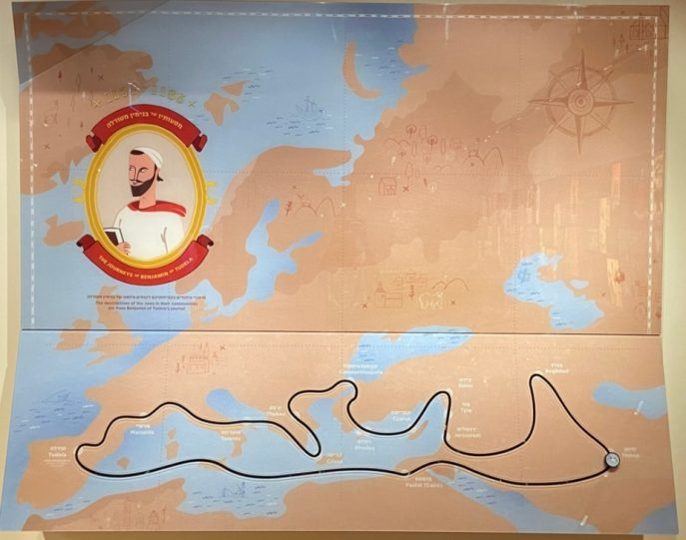
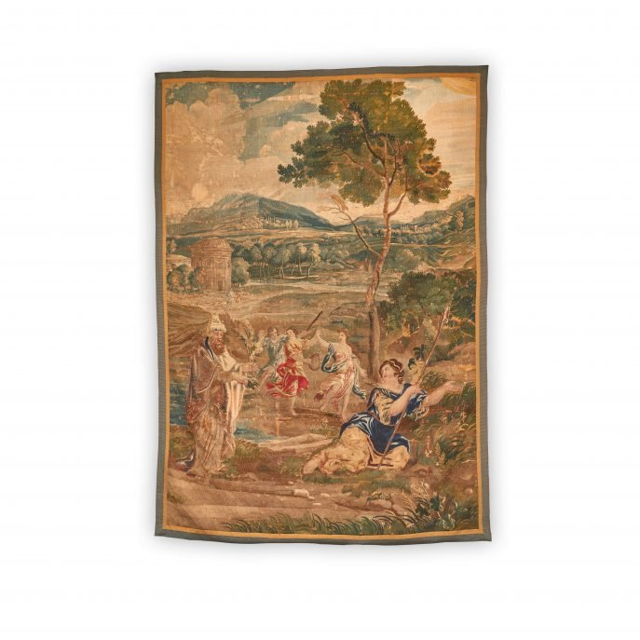 | 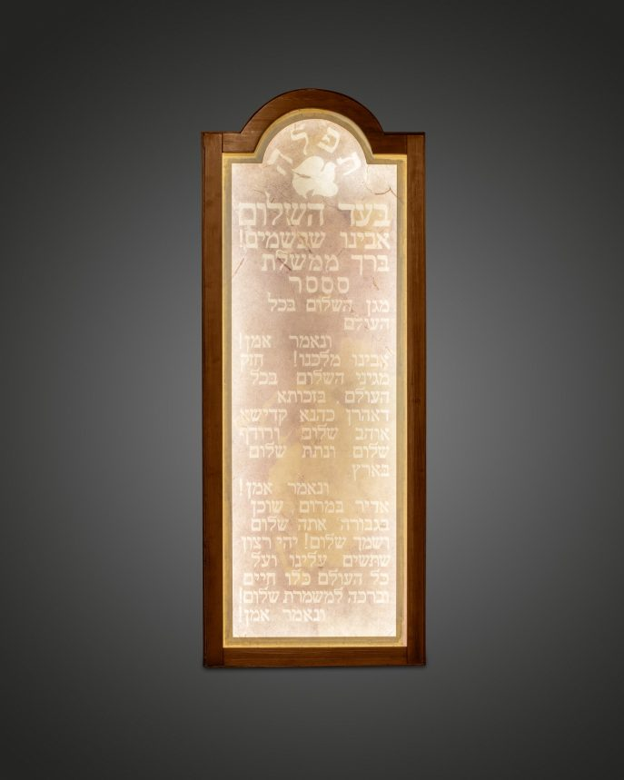 | 